Problem Statement 1
Microsoft Azure, formerly known as Windows Azure, is Microsoft's public cloud computing platform. It provides a range of cloud services, including compute, analytics, storage and networking. Users can pick and choose from these services to develop and scale new applications, or run existing applications in the public cloud.

The Azure platform aims to help businesses manage challenges and meet their organizational goals. It offers tools that support all industries -- including e-commerce, finance and a variety of Fortune 500 companies -- and is compatible with open source technologies. This provides users with the flexibility to use their preferred tools and technologies. In addition, Azure offers 4 different forms of cloud computing: infrastructure as a service (IaaS), platform as a service (PaaS), software as a service (SaaS) and serverless.

Microsoft charges for Azure on a pay-as-you-go basis, meaning subscribers receive a bill each month that only charges them for the specific resources they have used.

This Phase includes the describing the roles of
- Microsoft Azure works
- Microsoft Azure Uses
- Azure for DR and backup
- Pipeline creation
- Project and Management Creation with Azure board
- Azure & Git Connection
- Azure Monitoring

How Microsoft Azure work:
Once customers subscribe to Azure, they have access to all the services included in the Azure portal. Subscribers can use these services to create cloud-based resources, such as virtual machines (VM) and databases.

In addition to the services that Microsoft offers through the Azure portal, a number of third-party vendors also make software directly available through Azure. The cost billed for third-party applications varies widely but may involve paying a subscription fee for the application, plus a usage fee for the infrastructure used to host the application.
Microsoft provides five different customer support options for Azure:
Basic, Developer, Standard, Professional Direct, Premier

These customer support plans vary in terms of scope and price. Basic support is available to all Azure accounts, but Microsoft charges a fee for the other support offerings.
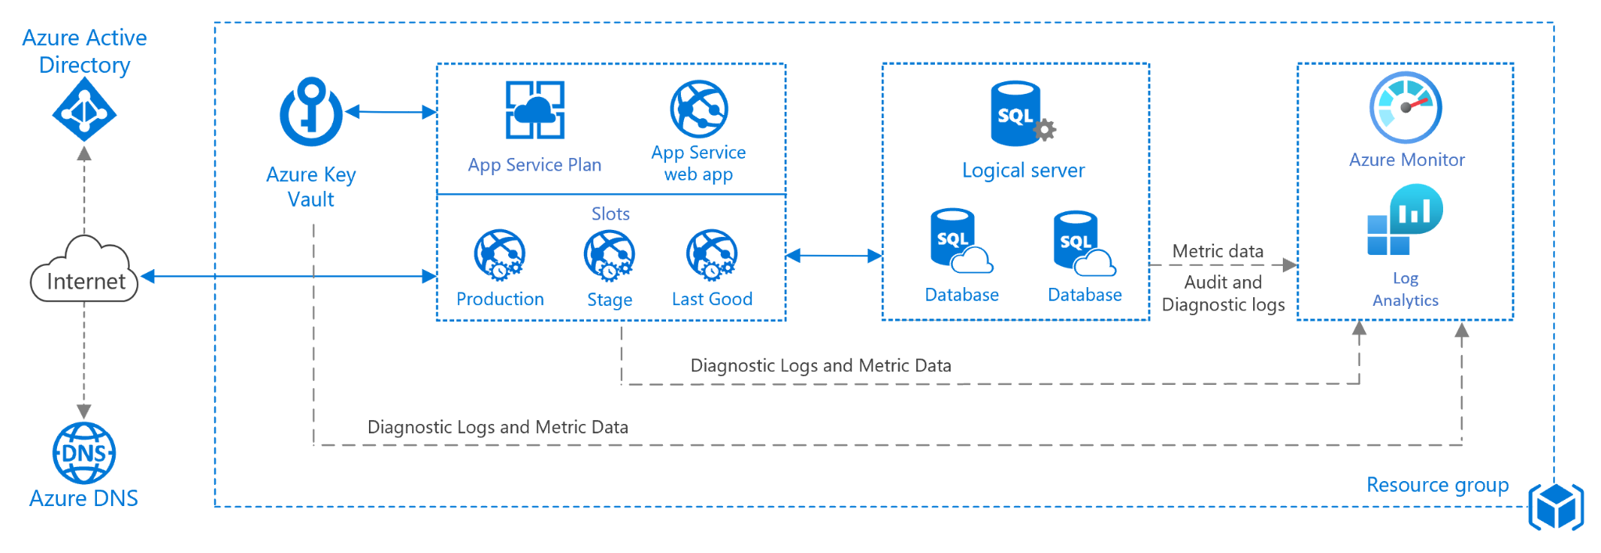
Microsoft Azure uses:
Because Microsoft Azure consists of numerous service offerings, its use cases are extremely diverse. Running virtual machines or containers in the cloud is one of the most popular uses for Microsoft Azure. These compute resources can host infrastructure components, such as domain name system (DNS) servers; Windows Server services -- such as Internet Information Services (IIS); or third-party applications. Microsoft also supports the use of third-party operating systems, such as Linux.

Azure is also commonly used as a platform for hosting databases in the cloud. Microsoft offers serverless relational databases such as Azure SQL and non-relational databases such as NoSQL.

In addition, the platform is frequently used for backup and disaster recovery. Many organizations use Azure storage as an archive in order to meet their long-term Data retention requirements.

Azure products and services
- Compute
- Mobile
- Web
- Storage
- Analytics
- Networking
- Media and content delivery network (CDN)
- Integration
- Identity
- Internet of things
- DevOps
- Development
- Security
- Artificial intelligence (AI) and machine learning
- Containers
- Databases
- Migration
- Management and governance
- Mixed reality
- Blockchain
- Intune

Azure for DR and backup:
Azure as an alternative to their own data center. Rather than invest in local servers and storage, these organizations choose to run some, or all, of their business applications in Azure. Unfortunately, not all services are available in all regions. Therefore, Azure users must ensure that workload and data storage locations comply with all prevailing compliance requirements or other legislation.
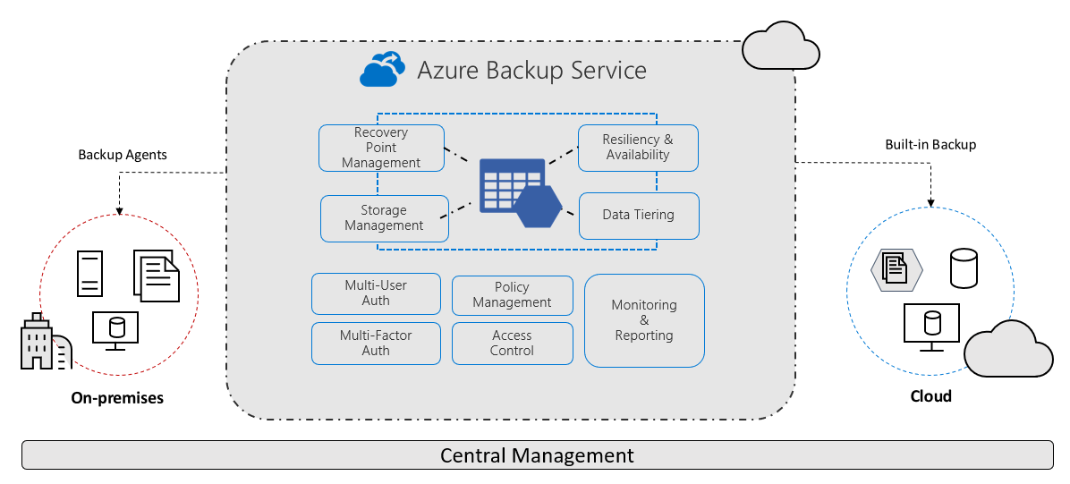
Pipeline creation:
- Sign in to your Azure DevOps organization and navigate to your project.
- Go to Pipelines, and then select New Pipeline.
- Walk through the steps of the wizard by first selecting GitHub as the location of your source code.
- You might be redirected to GitHub to sign in. If so, enter your GitHub credentials.
- When the list of repositories appears, select your repository.
- You might be redirected to GitHub to install the Azure Pipelines app. If so, select Approve & install.

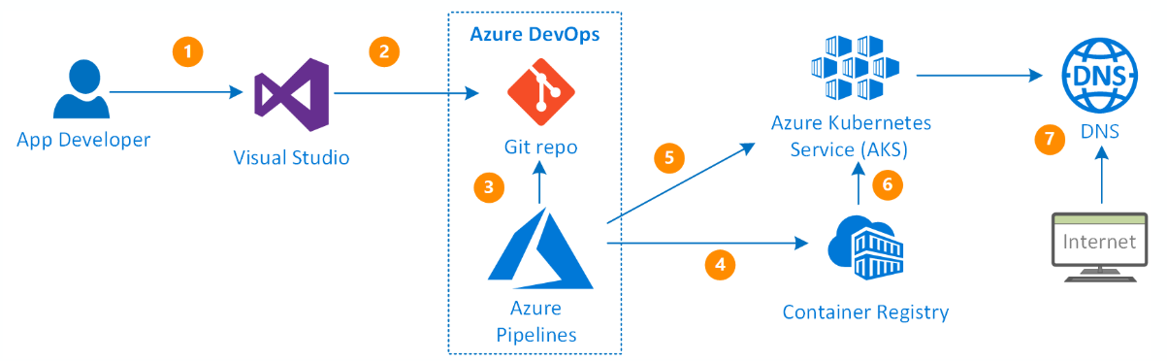
When the Configure tab appears
- When a new pipeline appears, take a look at the YAML to see what it does. When you're ready, select Save and run.
- Commit a new azure-pipelines.yml file to the repository. Select Save and run again.
- If you want to watch the pipeline in action, select the build job.
- Just created and ran a pipeline that automatically created, because code appeared to be a good match for the ASP.NET Core template.
- When ready to make changes to the pipeline, select it in the Pipelines page, and then Edit the azure-pipelines.yml file.

Project and Management Creation with Azure board:

Agile Project Management :

Working with teams, areas, and iterations:
- Navigate to Parts Unlimited project on Azure DevOps.
- Open the settings page using the Project settings navigation located at the bottom left of the page.
- Select the Teams tab. There are already a few teams in this project.
- Use “PUL-Web” as the Team name and click Create team (Leave defaults).
- Select the newly created team to view its details.
- By default, the new team has only user himself as its member.
- Select the Iterations tab and click Select iterations.
- Select Parts Unlimited\Sprint 1 and click Save and close.
- Repeat the process to add Sprint 2 and Sprint 3 (add them as in the previous step). The second sprint is our current iteration, and the third is in the near future.
- Select the Areas tab. By default, there is an area matching the name of the team.
- From the area dropdown, select Include sub areas. The default setting for all teams is to exclude sub-area paths.
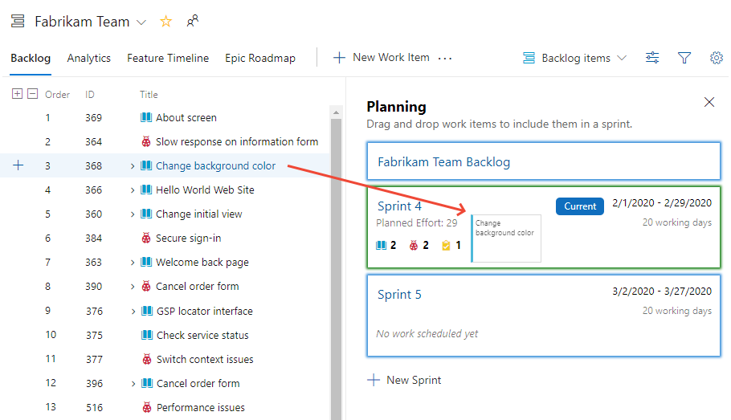

Working with work items:
Work items play a prominent role in Azure DevOps. Whether describing work to be done, impediments to release, test definitions, or other key items, work items are the workhorse of modern projects. In this task you’ll focus on using various work items to set up the plan to extend the Parts Unlimited site with a product training section. While it can be daunting to build out such a substantial part of a company’s offering, Azure DevOps and the Scrum process make it very manageable.
- Navigate to Overview | Dashboards.
- Select the Overview dashboard for Parts Unlimited Team.
- There are many ways to create work items in Azure DevOps, and we’ll explore a few of them. Sometimes it’s as simple as firing one off from a dashboard. In the New Work Item form, type “Product training” and select the Epic type. Click Create.
- Assign the new work item to self and set the Area to Parts Unlimited\PUL-Web. Set the Iteration to Parts Unlimited\Sprint 2 and click Save & Close. Ordinarily we would want to fill out as much information as possible
- Navigate to Boards | Work Items.
- Locate the newly created epic for Product training and open it.
- The work item form includes everything we could ever want to know about a work item. One of the key areas to focus on is Related Work. One of the ways to add a feature to this epic is to select Add link | New item.
- Set the Work item type to Feature and set the Title to “Training dashboard”. Click OK.
- That Assignment, Area, and Iteration should already be set to the same as the epic, and it’s even linked to the parent item it was created from. Click Save & Close.
- Navigate to the Board's view.
- Select PUL-Web Boards. This will open the board for that particular team.
- Switch the board from showing Backlog items to showing Features.
- From the Training dashboard dropdown, select Add Product Backlog Item.
- Name the first backlog item “As a customer, I want to view new tutorials” and press Enter to save.
- Add two more PBIs designed to enable the customer to see their recently viewed tutorials and to request new tutorials.
- Switch the task board view back to Backlog items.
- Backlog items have a state that defines where they are relative to being completed.
- You can also expand work item cards to get to conveniently editable details.
- Assign the moved PBI to self. Drag the second work item to the Committed stage.
- Drag the final PBI to the Done stage.
- The task board is one view into the backlog. View the tabular form by clicking View as Backlog.
- Click the Expand button, which allows you to view nested tasks under these work items.
- Set the Title, Remaining Work and the Activity. Click Save & Close.

Azure & Git Connection :
GitHub for software development while using Azure Boards to plan and track work. When we make the connection from Azure Boards, the list of GitHub repositories correspond to ones that we allow Azure Boards to access. We can limit which repositories Azure Boards can access overall, and limit what a particular project can access or split the management of work across different Azure Boards projects.
- Sign into Azure Boards for the project we want to connect to GitHub repositories.
- Choose Project Settings> GitHub connections.
- If it is the first time making a connection from the project, choose Connect GitHub account to use GitHub account credentials. Otherwise, choose New connection, and select authentication method from the New Connection dialog. 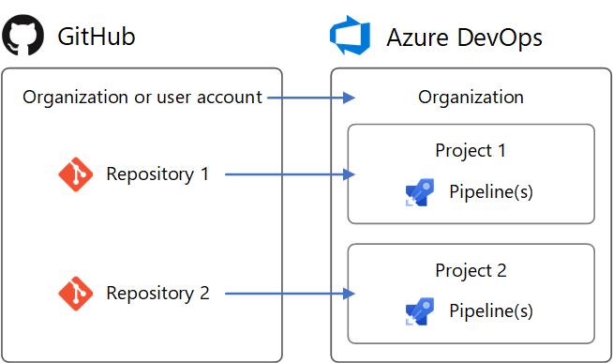

Azure Monitoring:
Azure Monitor helps you maximize the availability and performance of your applications and services. It delivers a comprehensive solution for collecting, analyzing, and acting on telemetry from your cloud and on-premises environments. This information helps you understand how your applications are performing and proactively identify issues affecting them and the resources they depend on.
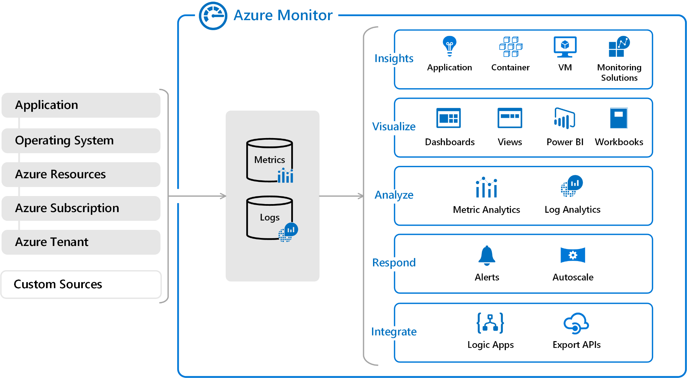
Monitoring data platform:
Azure Monitor fits into one of two fundamental types, metrics and logs.
Metrics:
Metrics are numerical values that describe some aspect of a system at a particular point in time. They are lightweight and capable of supporting near real-time scenarios. Logs contain different kinds of data organized into records with different sets of properties for each type.
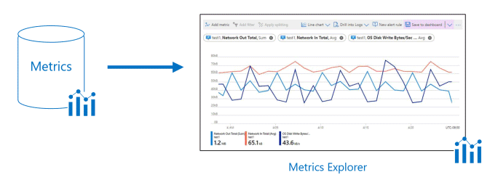

Logs:
Log data collected by Azure Monitor can be analyzed with queries to quickly retrieve, consolidate, and analyze collected data. You can create and test queries using Log Analytics in the Azure portal. You can then either directly analyze the data using different tools or save queries for use with visualizations or alert rules.
Azure Monitor uses a version of the Kusto query language that is suitable for simple log queries but also includes advanced functionality such as aggregations, joins, and smart analytics. You can quickly learn the query language using multiple lessons. Particular guidance is provided to users who are already familiar with SQL and Splunk.
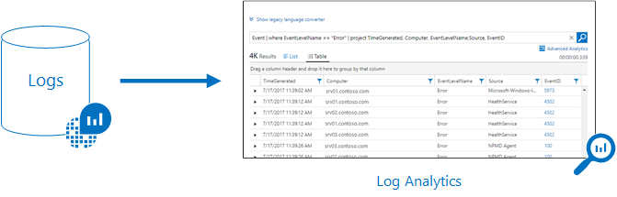

ANS:
Creating ci pipeline for dotnet project

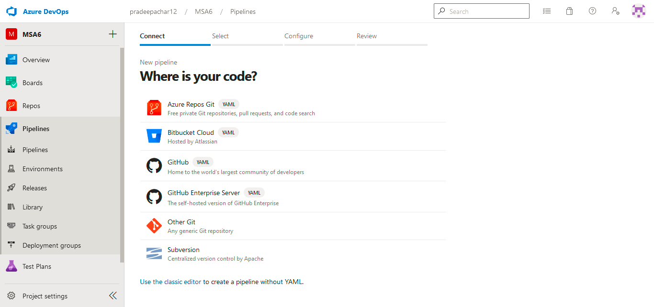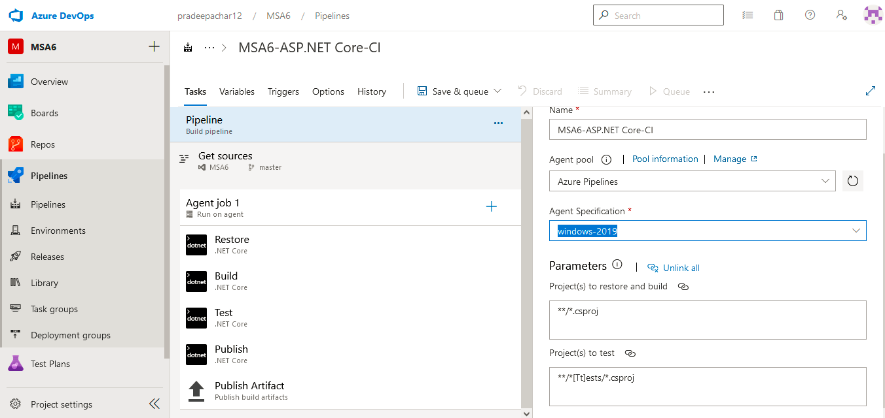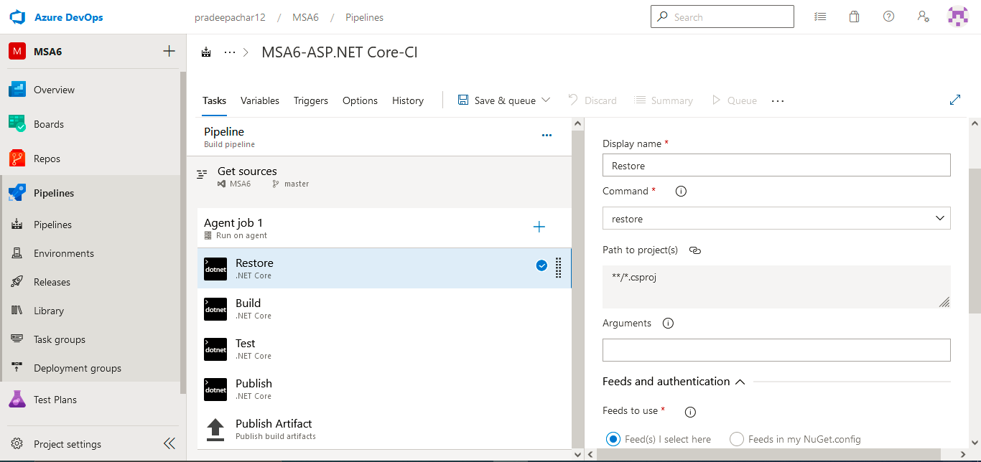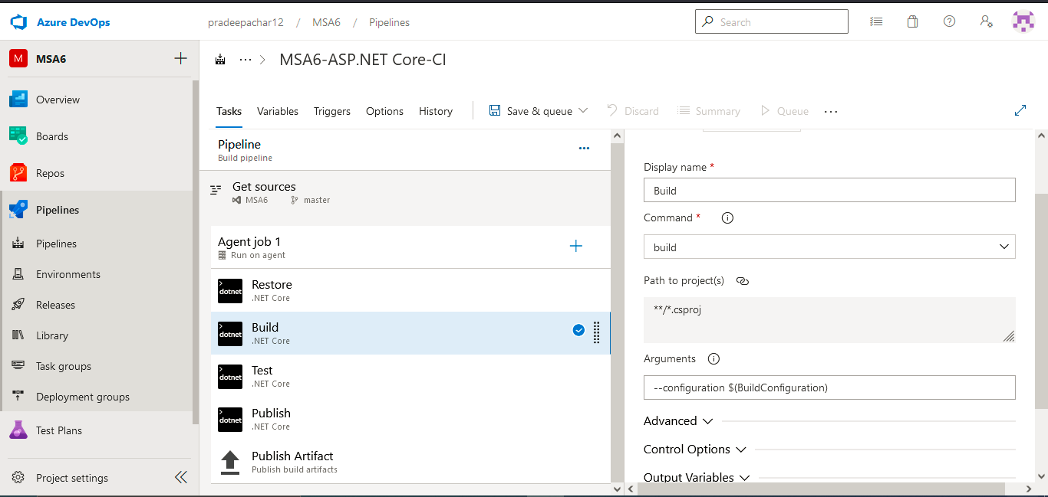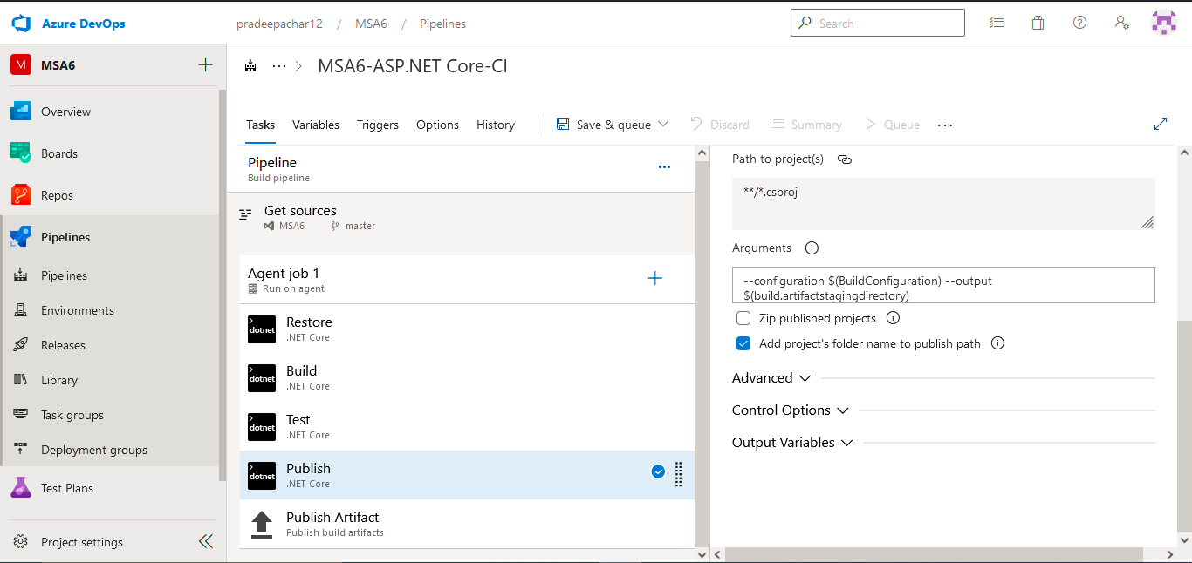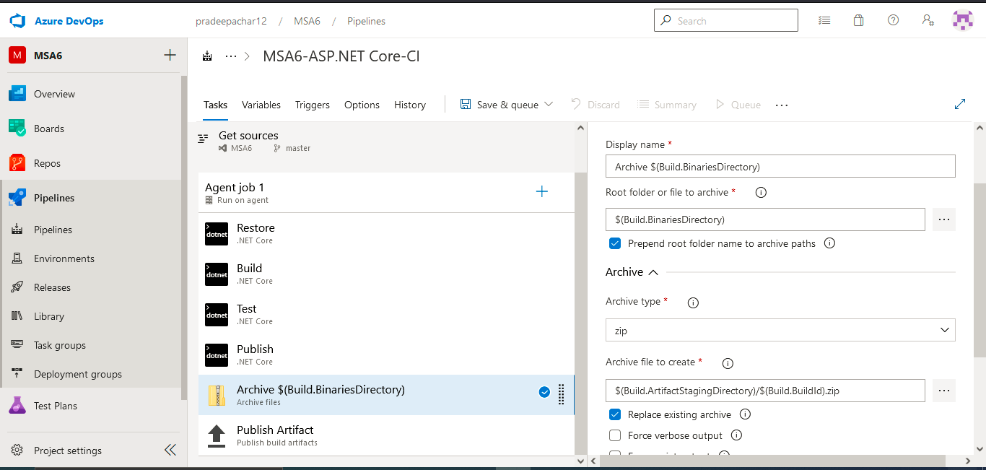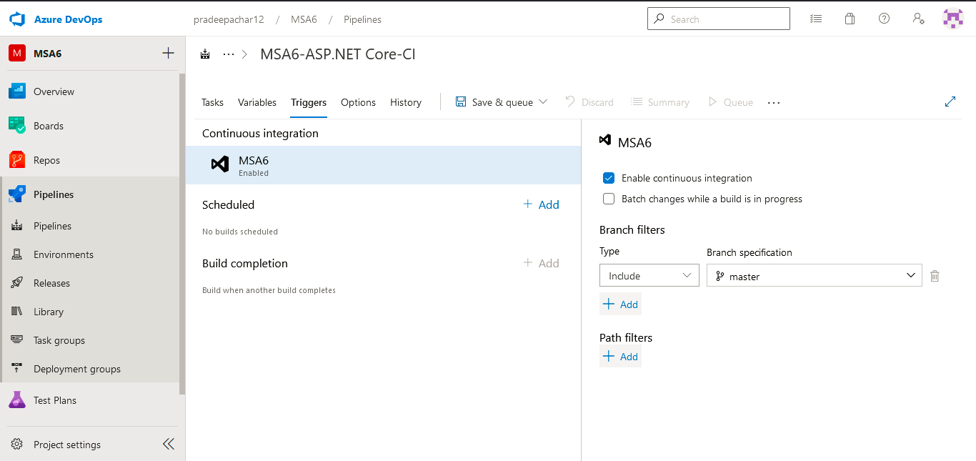

CD for dotnet project
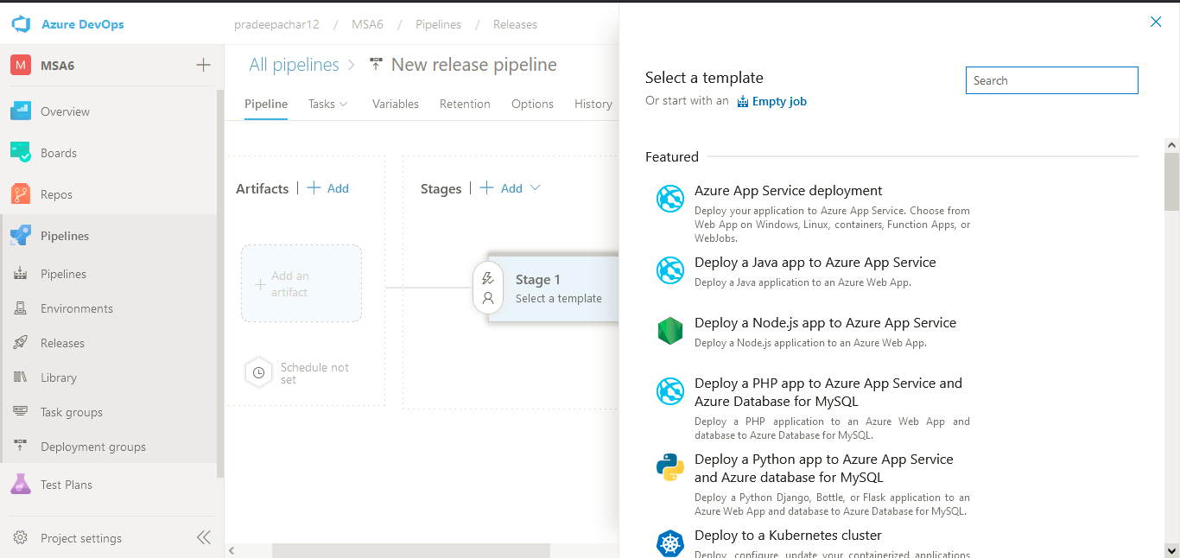
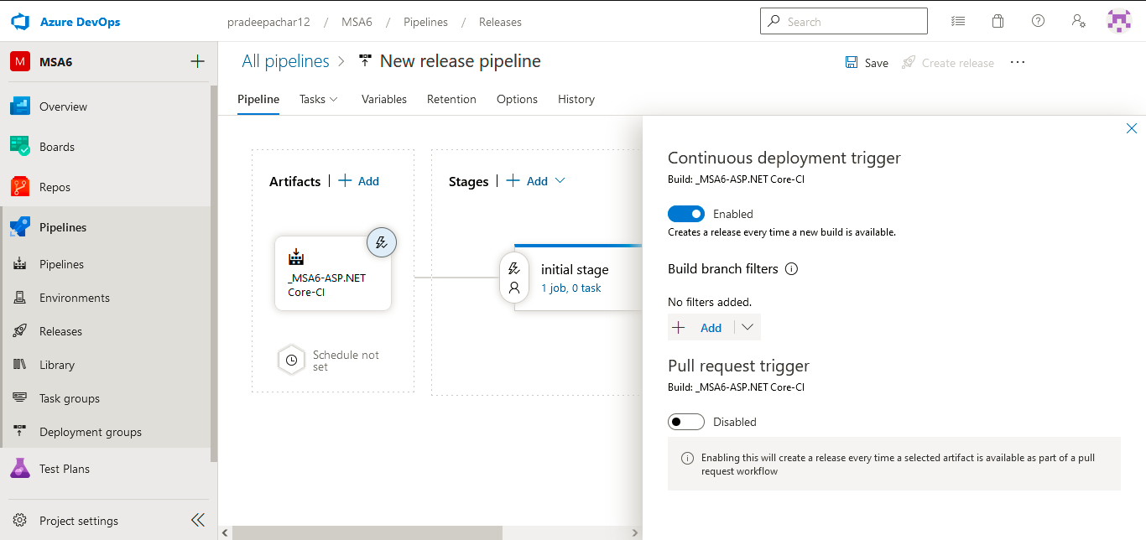

Agile Project Management:
Creating team
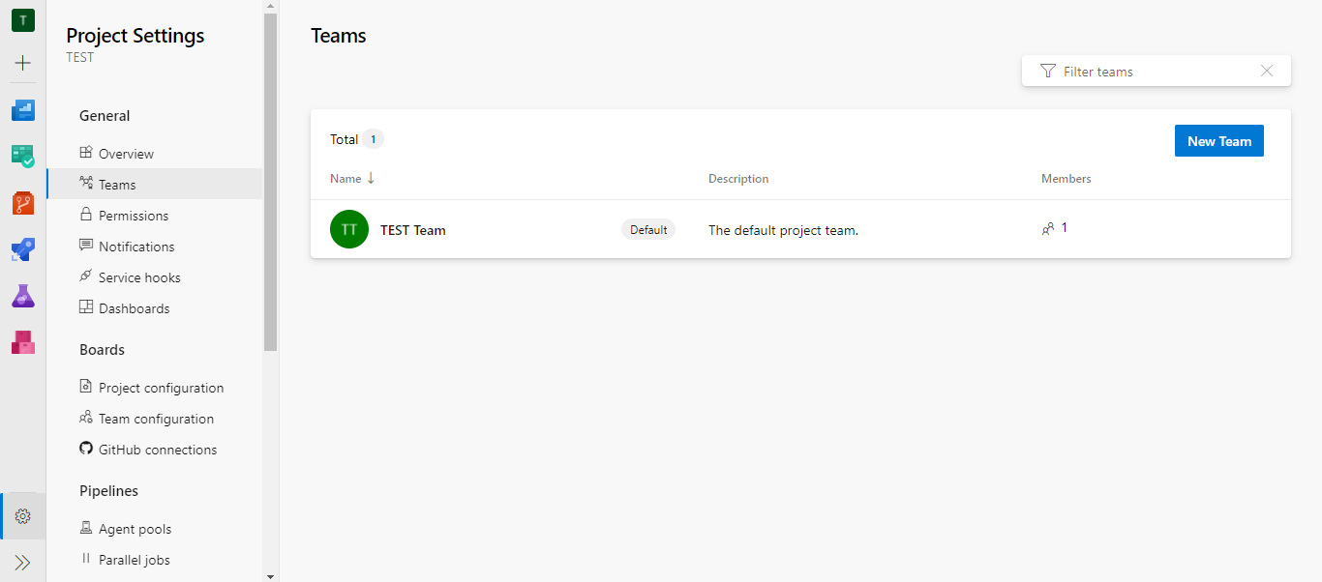
Creating Team:
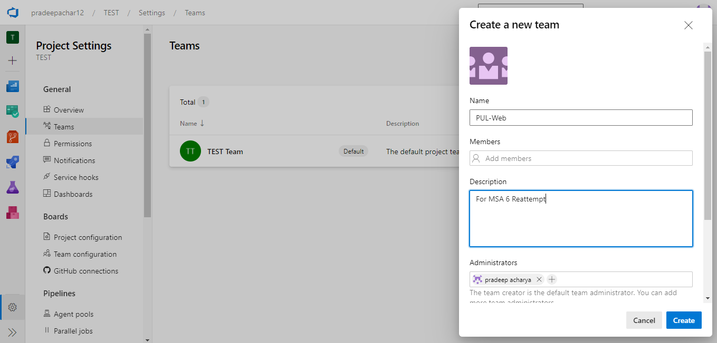
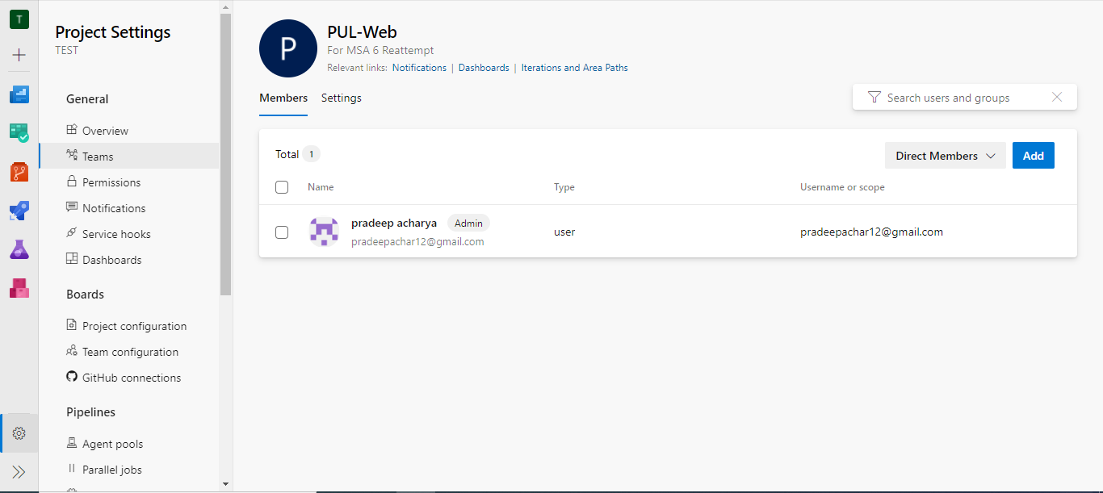
Creating Itirations:
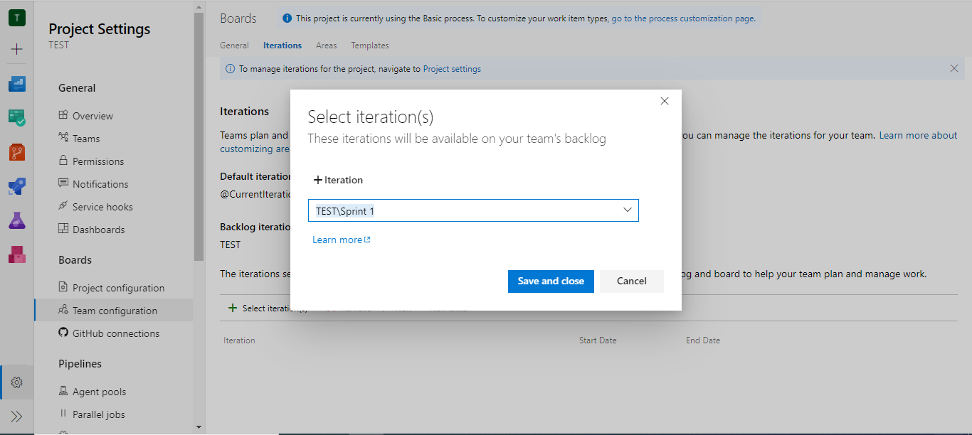
Creating Areas:
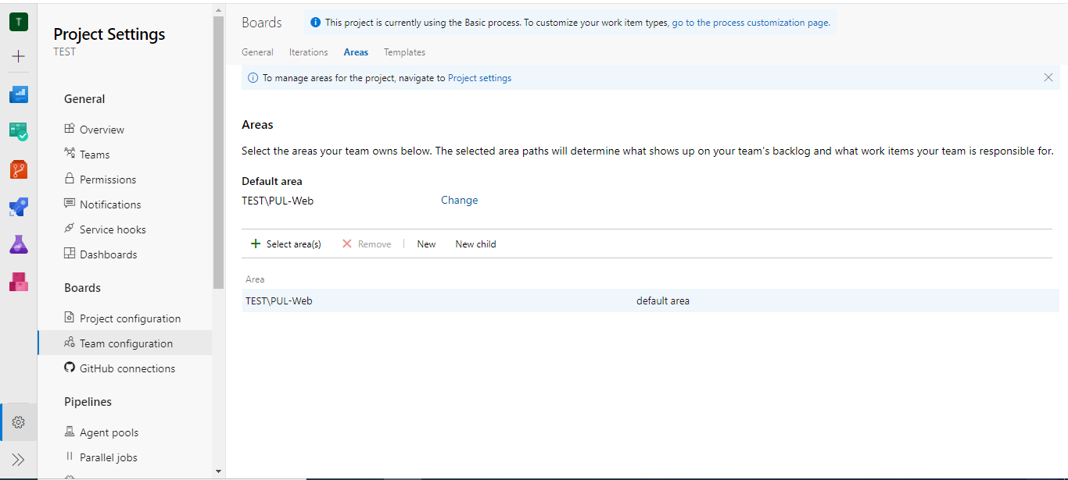

Working With work Items:
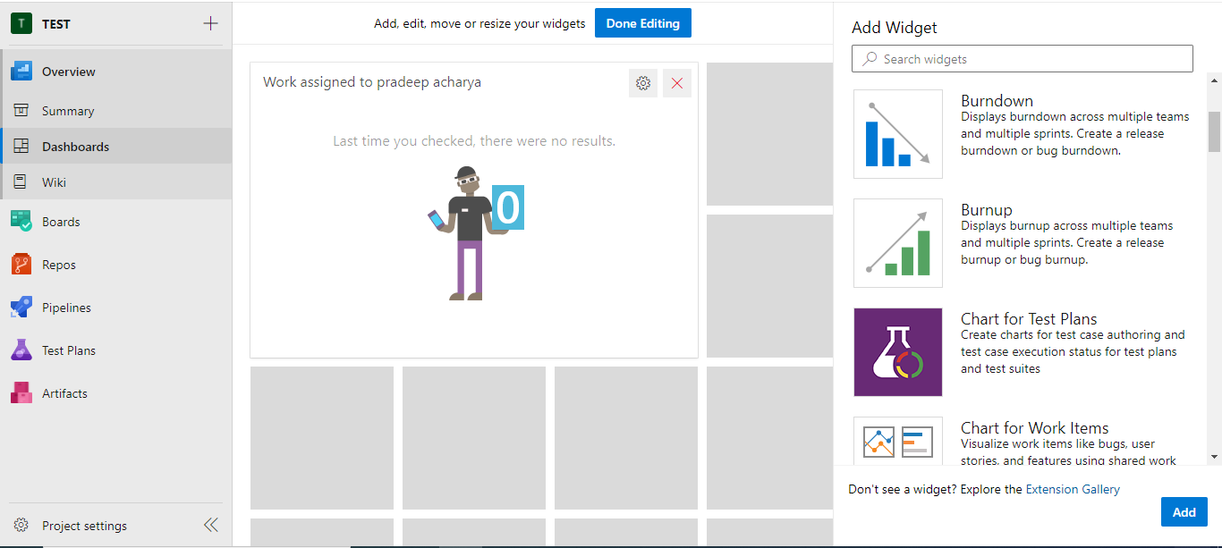
Work Item in Boards:
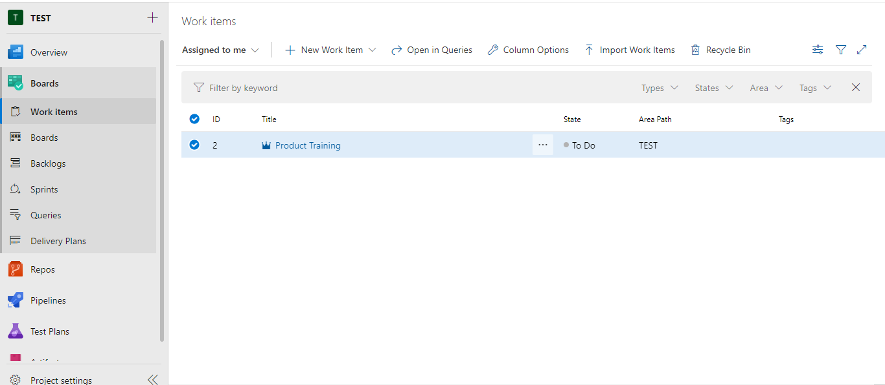
Creating new link for work item:
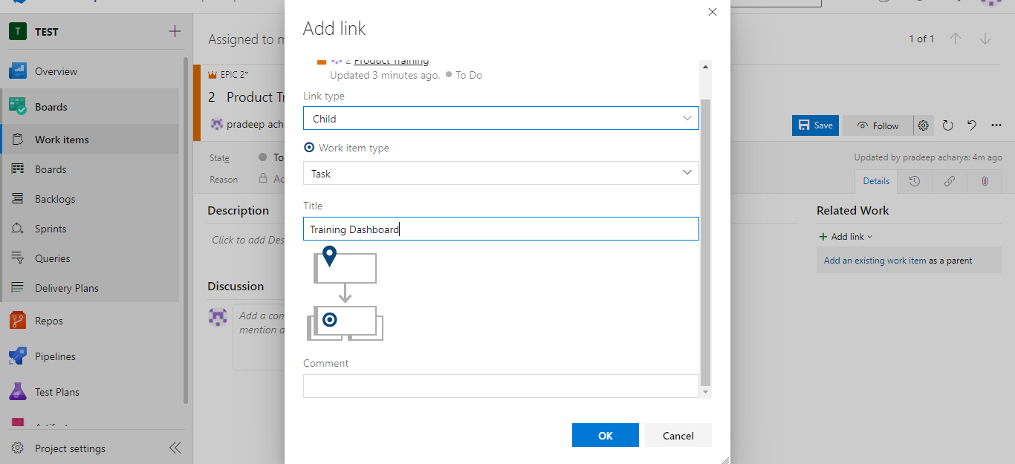
PUL-web board:
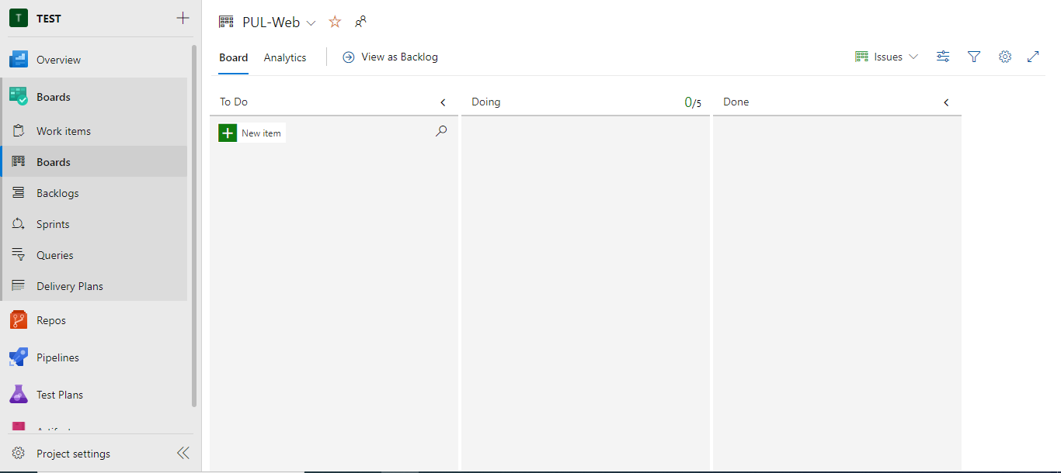
Editing work item cards:
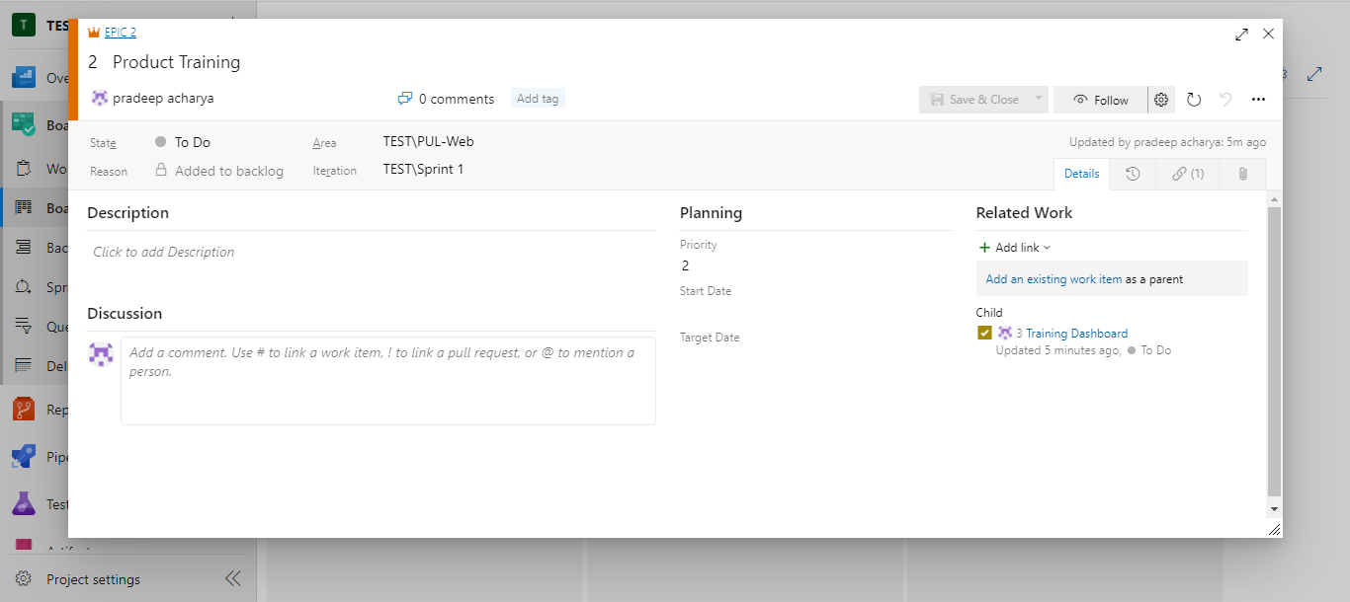

Azure git connection:
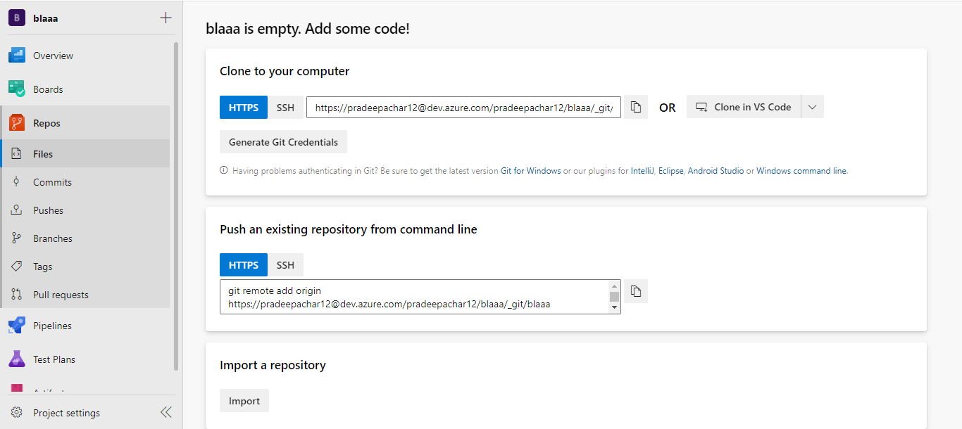
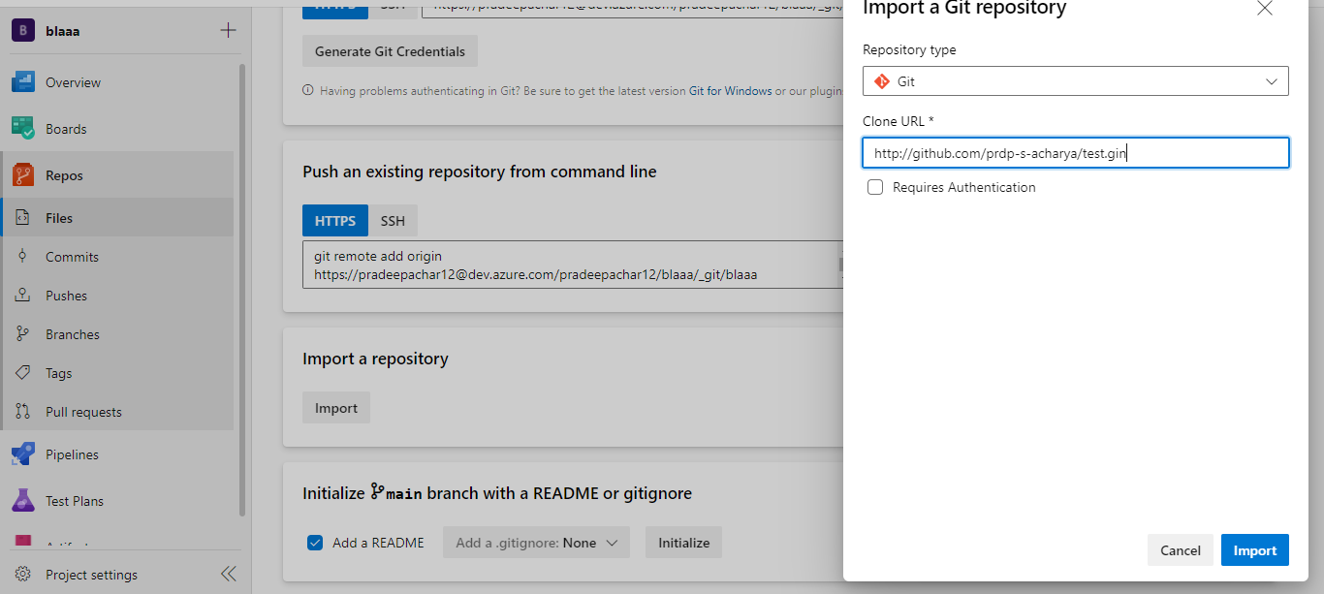

Azure Monitor Log:
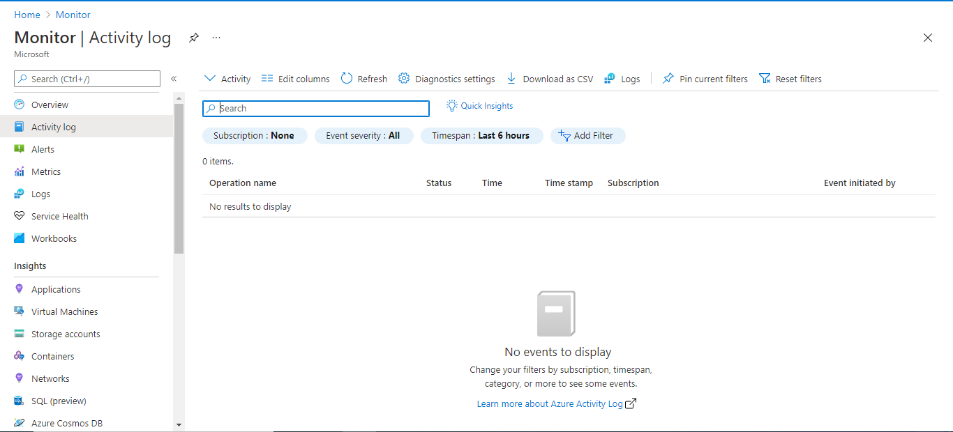
Azure monitor Matrix:
